**Lesson Topic: Responsible Use of Technology**

**Objectives:**

* Define Sexting
* Describe Sexting laws in NV
* Define what sexually explicit media is and the many places it’s found
* Explain ways in which media representations of sex and sexuality can affect sexual and romantic relationships

**Activities:**

Video: Teen Voices: Sexting, Relationships, and Risks <https://youtu.be/IZwVT6WnPQY>

Internet Danger-Everyone Knows Sarah <https://youtu.be/ThxmgXMBpoM>

#ThinkTwice-Your Digital Footprint Matters <https://youtu.be/9eSxZPu4oqQ>

Class discussion of NV Sexting Laws and what is considered child pornography

Work with a small group to read and respond to sexting scenarios

Review everyday ads that contain sexually explicit images and discuss reasons companies are choosing these types of ads and how they can affect romantic and sexual relationships.

**NV Sexting Laws**

Background info for teachers

**NRS 200.737  Use of electronic communication device by minor to possess, transmit or distribute sexual images of minor; penalties.**

      1.  A minor shall not knowingly and willfully use an electronic communication device to transmit or distribute a sexual image of himself or herself to another person.

      2.  A minor shall not knowingly and willfully use an electronic communication device to transmit or distribute a sexual image of another minor who is older than, the same age as or not more than 4 years younger than the minor transmitting the sexual image.

      3.  A minor shall not knowingly and willfully possess a sexual image that was transmitted or distributed as described in subsection 1 or 2 if the minor who is the subject of the sexual image is older than, the same age as or not more than 4 years younger than the minor who possesses the sexual image. It is an affirmative defense to a violation charged pursuant to this subsection if the minor who possesses a sexual image:

**https://www.leg.state.nv.us/Division/Legal/LawLibrary/NRS/NRS-200.html#NRS200Sec737**

WCSD Policy 5700- Safe and Respectful Learning Environment

“Cyber-bullying” means bullying through the use of electronic communication. The term includes the use of electronic communication to transmit or distribute a sexual image of a minor. (NRS 388.123)

Department of Justice: Federal law

<https://www.justice.gov/criminal-ceos/citizens-guide-us-federal-law-child-pornography>

Lesson:

* Brainstorm and discuss uses of technology
  + Professional uses
  + Personal uses
  + Possible consequences

Slide 2: What about “Sexting?”

* + What is it

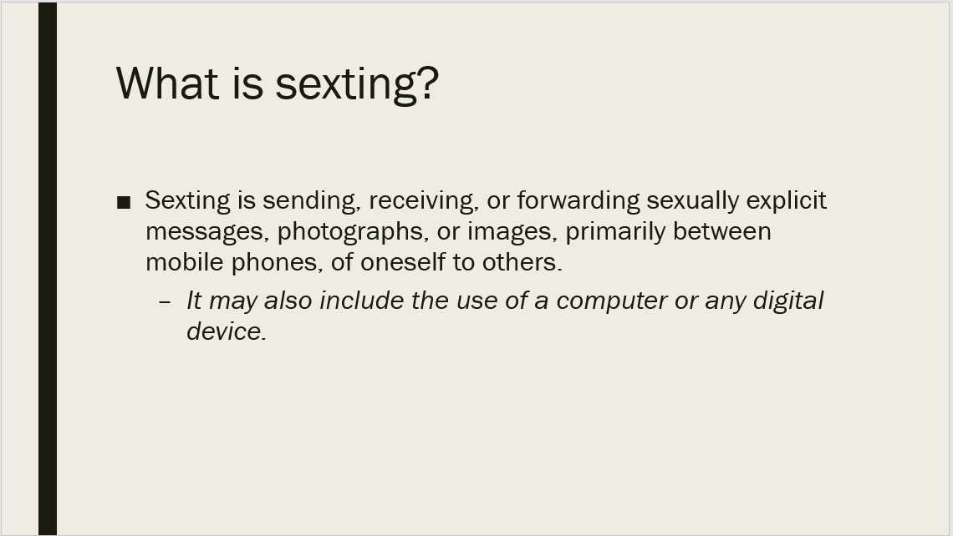

* What do you think about sexting?
* Why do you think some people might sext?

*Sexually explicit is often used as euphemism for pornography-it includes unsimulated sex acts, sexual intercourse and uncovered genitalia.*

*Full nudity refers to complete nudity, while partial nudity refers to* ***less than full nudity****, with parts of the body covered in some manner. The term "partial nudity" is sometimes used to refer to exposure of skin beyond what the person using the expression considers to be within the limits of modesty.*

Slide 3: Sexting, Relationships and Risks YouTube video

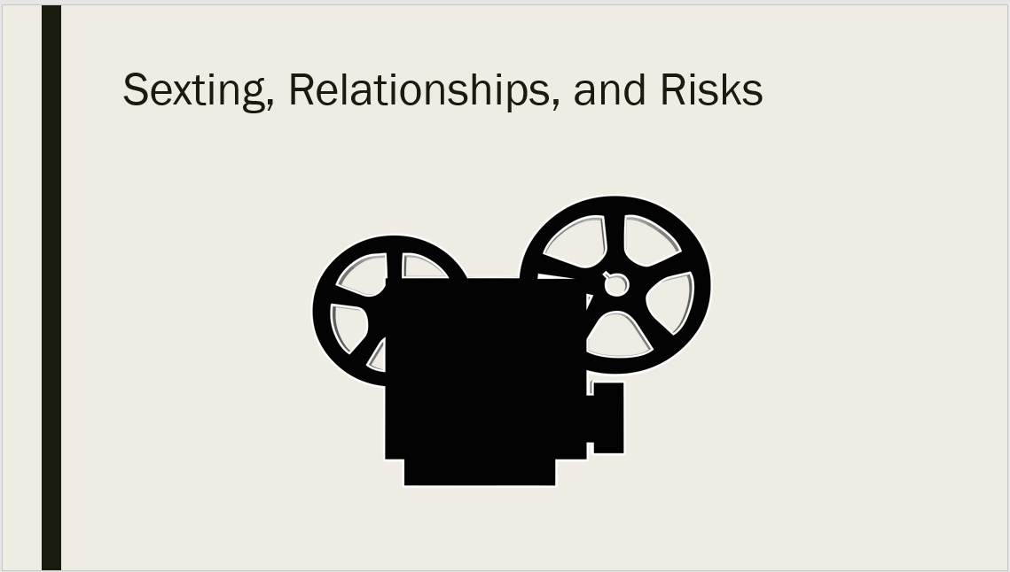

Slide 4: Play video, *Everyone Knows Sara*



As evident in the video, there are emotional ramifications of sexting.

What about legal consequences?

Slide 4: Are you aware that?

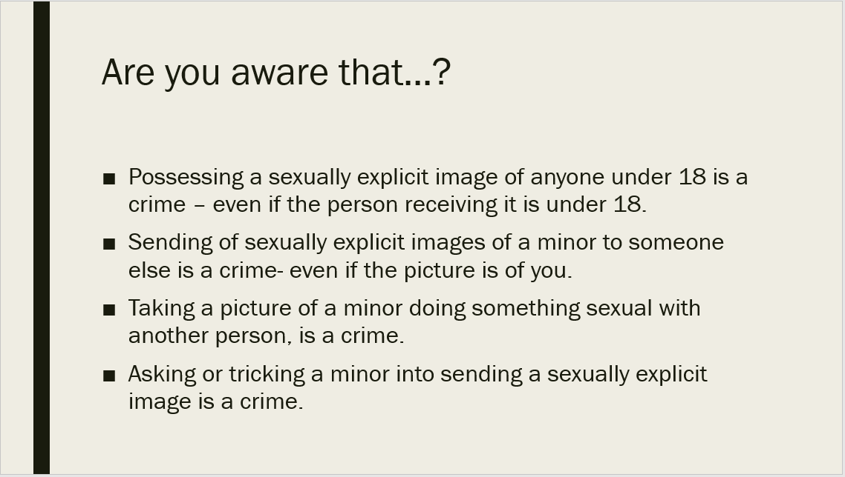

Laws regarding sexting are different from state to state, but what they do have in common is that a naked photo of someone under the age of 18 is considered child pornography and child pornography is illegal.

Slide 6: What does NV law say?

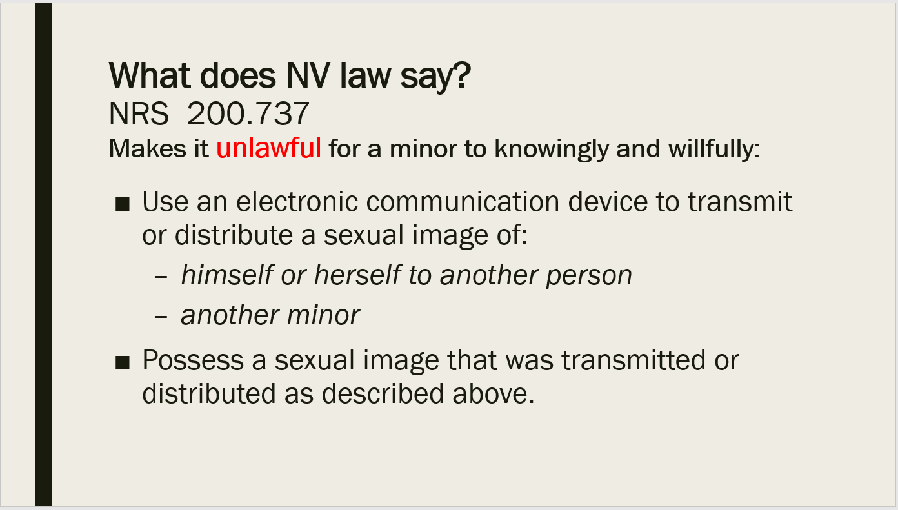

Slide 7: Legal ramifications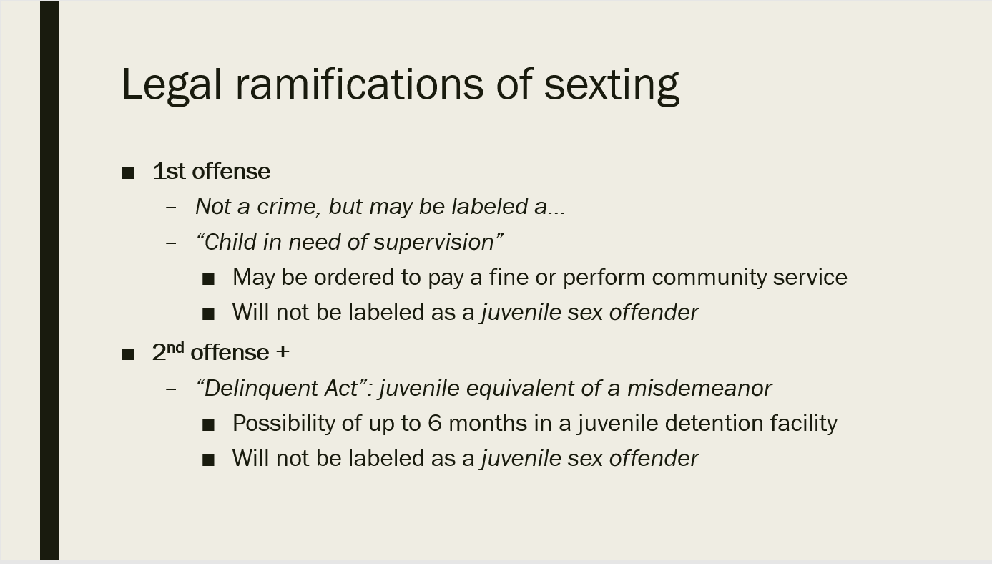

Slide 8: What happens if you are over 18 years old?

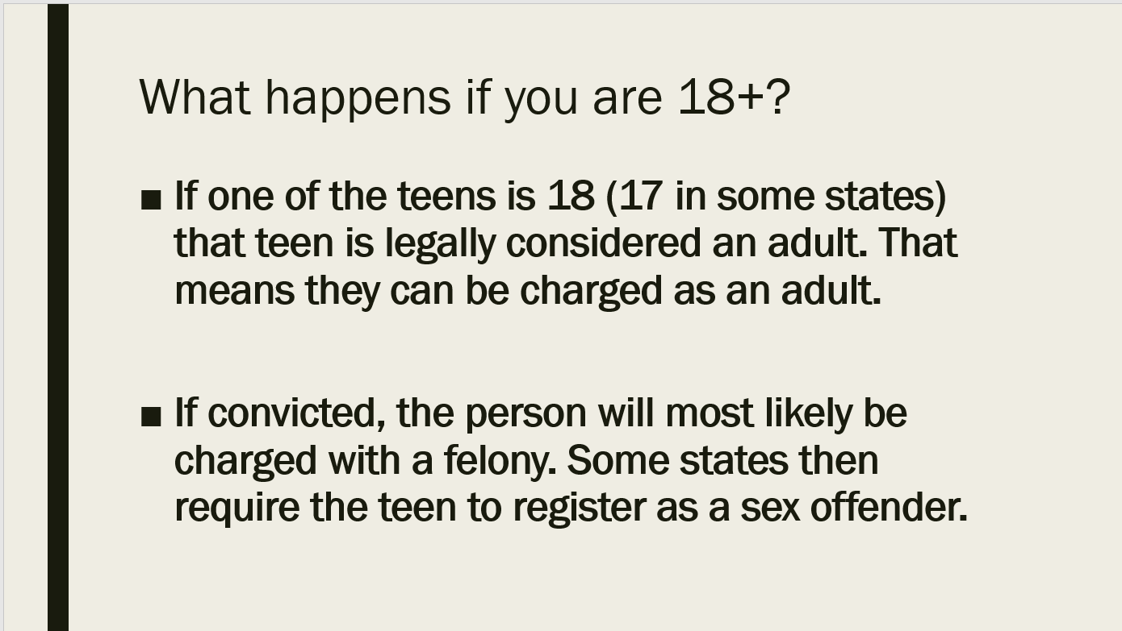

Slide 9: What happens if you move across state lines to CA? What are the laws there?

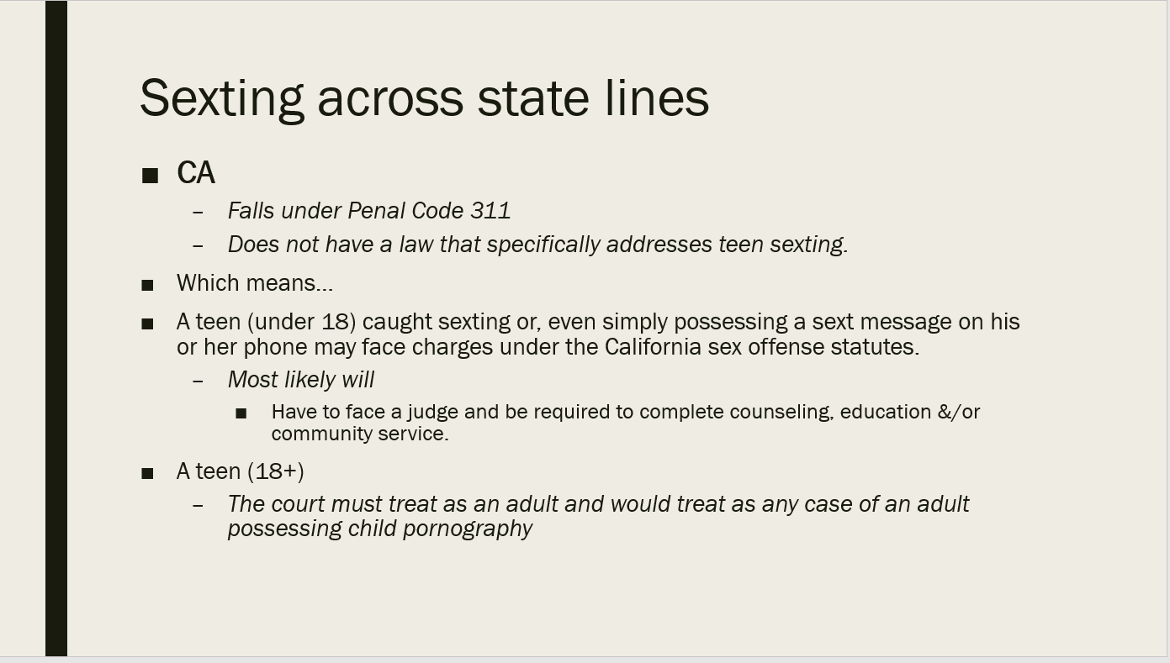

**Sexting Scenarios Activity:**

* Divide the class into groups of three. Distribute the scenarios relating to sexting and ask them

to discuss what they would do and then write their ideas down on the worksheet. Tell them they have about ten minutes in which to work.

* + Can also be done as posters on the wall. Post the 3 scenarios up on each side of the room and divide students into 6 groups. Have an A side and B side of the room (the same 3 posters are up on each side). Group them by A-1, A-2, A-3, B-1, B-2, B-3. Have students rotate through posters. Provide 3-5 minutes per poster.

**SCENARIO ONE**

Another student at school has started asking your friends about you. You think they’re kind

of cute and might be interested in something with them, but you’re not quite sure. Somehow,

they get your cell number and text you, “Hey.” You’re not expecting that, so you text back,

“Who is this?” The answer you get is, “It’s me,” followed by a naked picture of them.

What should you do?

**SCENARIO TWO**

You’re in a relationship with someone, and you’re really into each other. Part of your

relationship is to send sexy texts back and forth, talking about how attracted you are to each

other. One day, your partner texts, “How about sending me something I can look at and think

of you?” You don’t see anything wrong with it, especially since things are so good between

you. You send a naked pic with the text, “Just 4 you, k?” They text back how much they love

it. The next day, three different people tell you how hot they thought your picture was.

What should you do?

**SCENARIO THREE**

You and your partner have been together for 3 months. You like each other’s friends, you like

spending time together, you’re really in sync with what you do and don’t like sexually. You

have sexted each other a few times, both texts and sexy photos. Neither of you has shared

your pictures with anyone else, and promised you never would. As the school year goes on,

you meet someone you click with instantly. You’re instantly hooked, and feel you need to be

the one to tell your partner that it’s over. Unfortunately, they find out from someone else and

freak out. They go to their Instagram account, and start posting the naked photos they have

of you online.

What should you do?

Slide 10: What should you do?

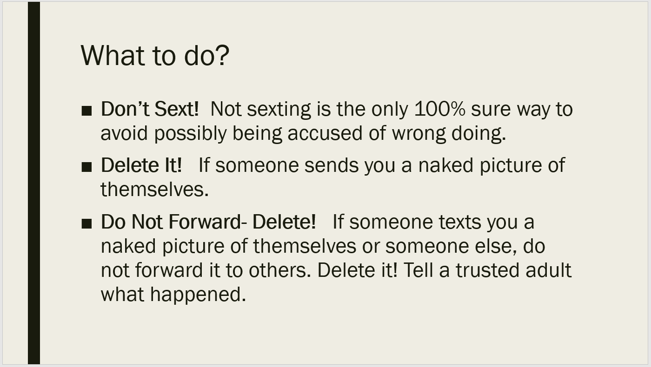

We’ve talked about sexting now let’s move on to sexually explicit images in various forms of media.

Sexually explicit was referenced when we talked about sexting, what does it mean when we talk about it in the media?

**Sexually Explicit materials**.

* What is the first thing that comes to mind? (probe for student responses)
  + Often it’s porn.
  + But what about the sexually explicit images we see every day

Plenty of images today on TV, online, social media sites, in magazines and elsewhere are very

sexual in nature. They get right up to the edge of what is allowable in the media. We’re

going to take a minute now to look at the possible messages that these sexual images

communicate.

Slide 11:

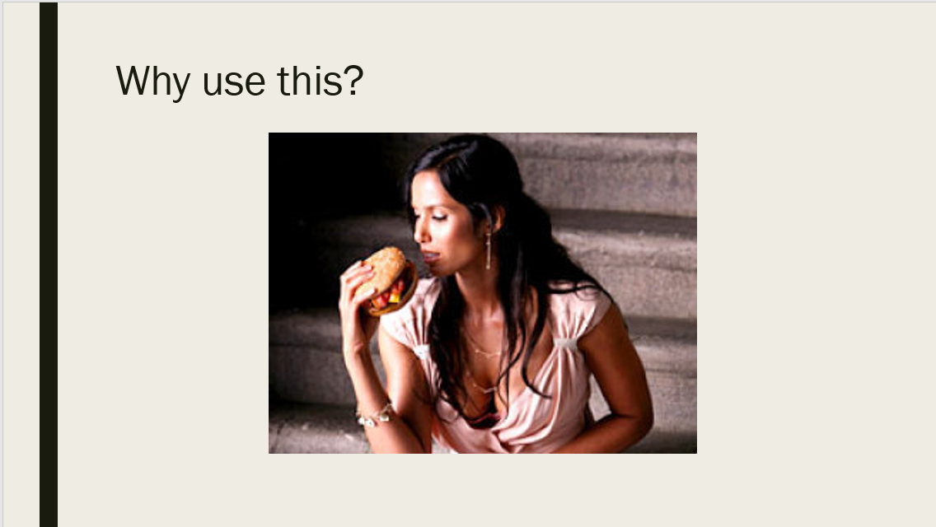

Slide 12:



Slide 13:

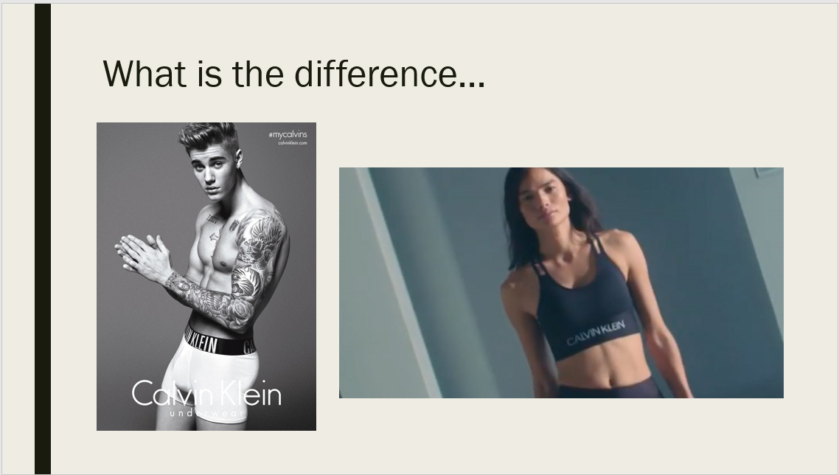

Slide 14:



Slide 15:



Slide 16:



Slide 17:



Discuss implications on the slide (below)

Slide 18:

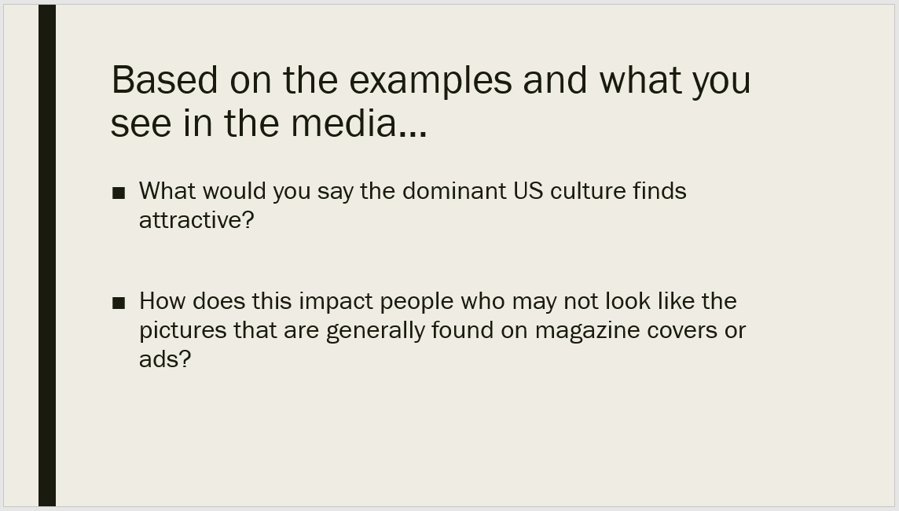

Provide the definition of Porn

How do the ads that you see in the media relate to the definition of “porn?”

Slide 19:

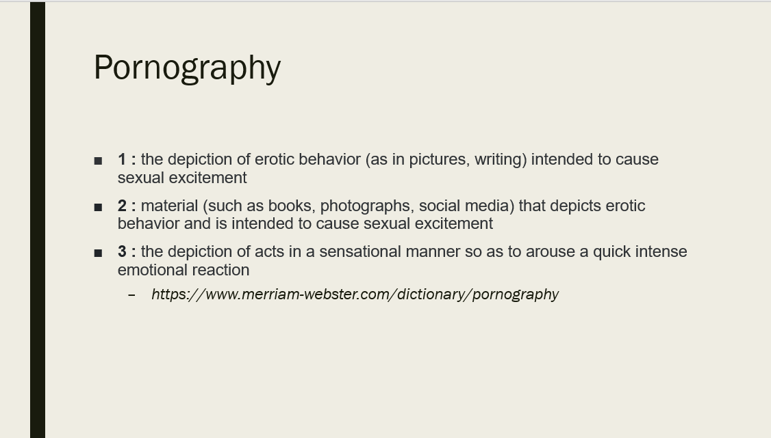

Finally, ask what they think the potential impacts of these expectations are on romantic and sexual relationships. This discussion will vary from class to class, but you will want to probe for:

Slide 20:

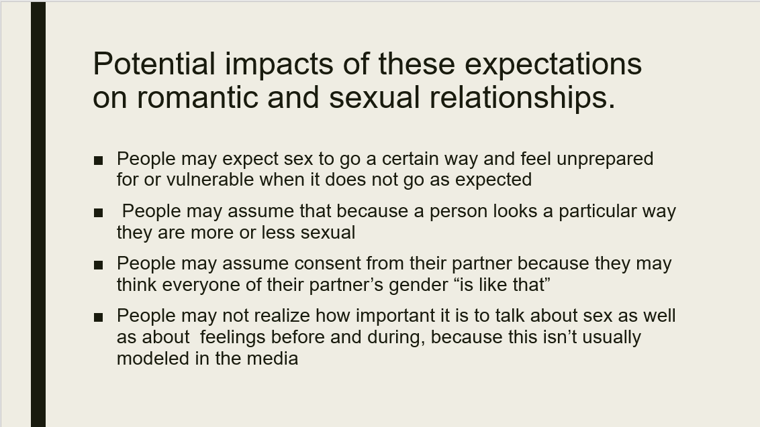

Slide 21:

